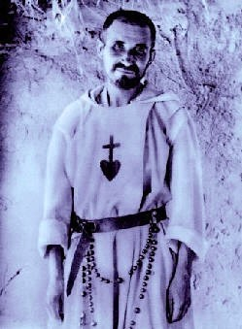

A 5 Day Retreat July 2023
Organised by the Jesus Caritas Priests’ Fraternities, under the patronage of St. Charles de Foucauld, but open to all Clergy who wish to enjoy a time for Adoration, Reflection & Prayerful Fraternity.

DATE: Monday3rd July (registration and tea: from 4pm)
to Friday7th July 2023 (depart after lunch)

BOOKING DEADLINE: Please book by 1st June 2023

Organiser: Fr. Barnabas Page (barnabas.page@gmail.com 0117 9833939)

Speaker: Mgr. Pat Kilgarriff

Venue: Nympsfield Convent, Front St. Nympsfield. Glos. GL10 3TZ
Please send booking form to Barnabas Page with £50 deposit
(balance of £250 payable at Nympsfield or in advance if possible )
Pay either by cheque “Jesus Caritas Fraternity”
or by BACS: JESUS CARITAS FRATERNITY
Sort Code: 60-19-14 Account Number: 34455906

Also let Barnabas know-

-If you will be driving and are willing to collect someone from Stroud or Gloucester station OR

-If you would like to be met at Stroud or Gloucester station.

_______________________________________________ detach here and send with deposit

Jesus Caritas Retreat 3rd to 7th July 2023
Booking Form (please print clearly)

NAME:

ADDRESS:

TEL. NUMBER: E-MAIL ADDRESS:

Any special dietary/mobility requirements:

Please book me in for the Jesus Caritas Recollection from Monday 3rd to Friday 7th July 2023

I enclose a £50 cheque made payable to ‘Jesus Caritas Fraternity’

or will transfer £50 by BACS for the deposit.

Send to: Fr. Barnabas Page. St Augustine’s Presbytery, Boscombe Crescent,
Downend, BRISTOL BS16 6QR

