
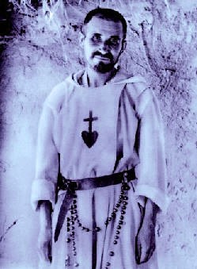
THE PRIESTLY FRATERNITIES OF JESUS CARITAS
A New Year Recollection 2019

Organised by the Jesus Caritas Priests’ Fraternities, under the patronage of Blessed Charles de Foucauld, open to all priests who wish to start the New Year with a time for Adoration, Reflection and Prayerful Fraternity.

Date: Tuesday 15th January (registration and tea: 3.30-4pm)
to Thursday 17th January (depart after lunch)
BOOKING DEADLINE To facilitate catering etc., bookings must be received by December 15th 2018 at the latest.
Organiser: Fr. Barnabas Page (barnabas.page@gmail.com)
Speaker: Adrian Toffolo
Venue: Carmelite Priory, Chilswell, Boars Hill, Oxford OX1 5HB
 01865 735133 e-mail: priory@carmelite.org.uk Website: www.carmelite.org.uk
Please send booking form to Boars Hill with £20 deposit (full cost approx £110 – to be confirmed ) but please also inform Barnabas Page that you will be attending.
- If you will be driving and are willing to collect someone from Oxford station OR …
- if you would like to be met at Oxford Station …
- please let Barnabas know.
__________________________ detach  here and send to Boars Hill________________________________
Jesus Caritas Recollection 15th to 17th January 2019
BOOKING FORM (please complete clearly in capitals)
To: Bookings to: The Administrator, Date: ____________________
Carmelite Priory, Chilswell, Boars Hill, Oxford OX1 5HB

NAME: ………………………………………………….……….……….. DIOCESE / RELIGIOUS ORDER …………..……………..…………….

ADDRESS: …………………………………………………………………….………………………………………………………………………………………

………………………………………………………………………………………………………..……………… POSTCODE ………………………………

TEL. NUMBER: ……………………………………..…. E-MAIL ADDRESS: ………………………………..…………………………………………

Please book me in for the Jesus Caritas Recollection from Tuesday 15th to Thursday 17th January 2019.
I enclose a £20 cheque made payable to ‘Carmelite Priory’ for the non-refundable deposit.
Special dietary/mobility requirements ………………………………………………………………………………………………

Signed: ______________________________________________

